**Experiment: 6**

PART A

(PART A: TO BE REFERRED BY STUDENTS)

**Aim:** Programming using 1D Array & 2D array

**Learning Outcomes:** The learner would be able to

1. Understand the syntax of array declaration, initialization
2. Traversing the arrays (1D or 2D)
3. Implement programs using arrays (1D or 2D)
4. Use appropriate array (1D, 2D or Multi-dimensional) depending on the problem statements

**Theory:**

**Programming constructs 1 – D and 2 - D arrays**

* It is group of logically related data, stored in contiguous blocks of memory under common name.
* An Array is homogeneous or similar type of data under common name.
* Data items or elements of arrays are separated by subscript or index.
* Array is an indirect pointer.
* C++ Supports following arrays.
  + One Dimensional Arrays
  + Two or Multi-Dimensional Arrays.
* One-dimensional arrays are represented as set of values in one row.
* Multi-dimensional arrays are views as table-containing data i.e. rows & columns.

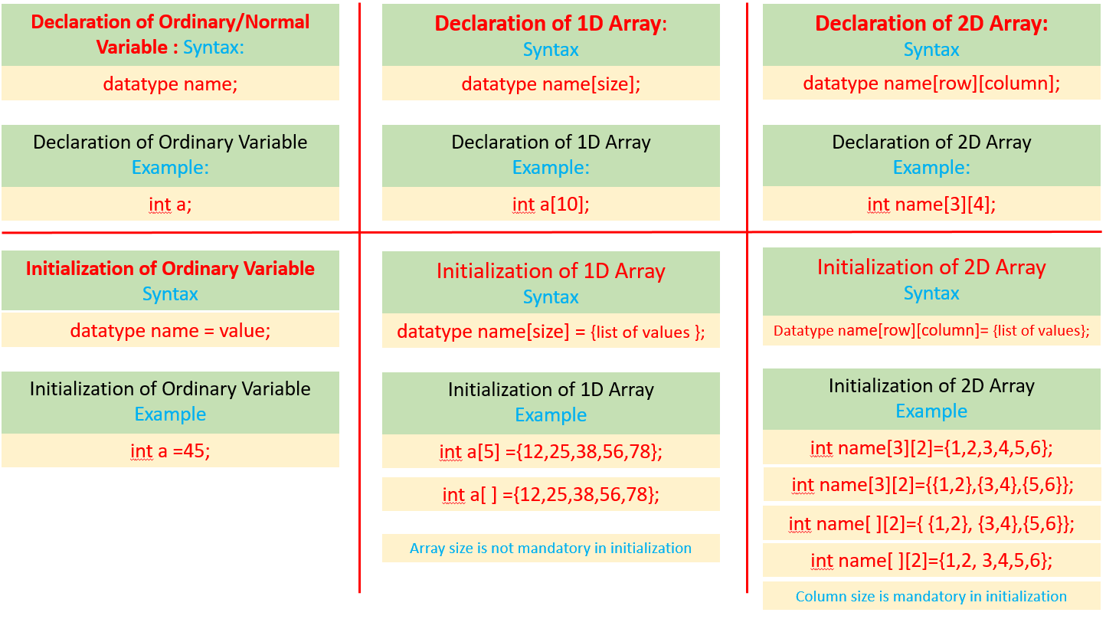

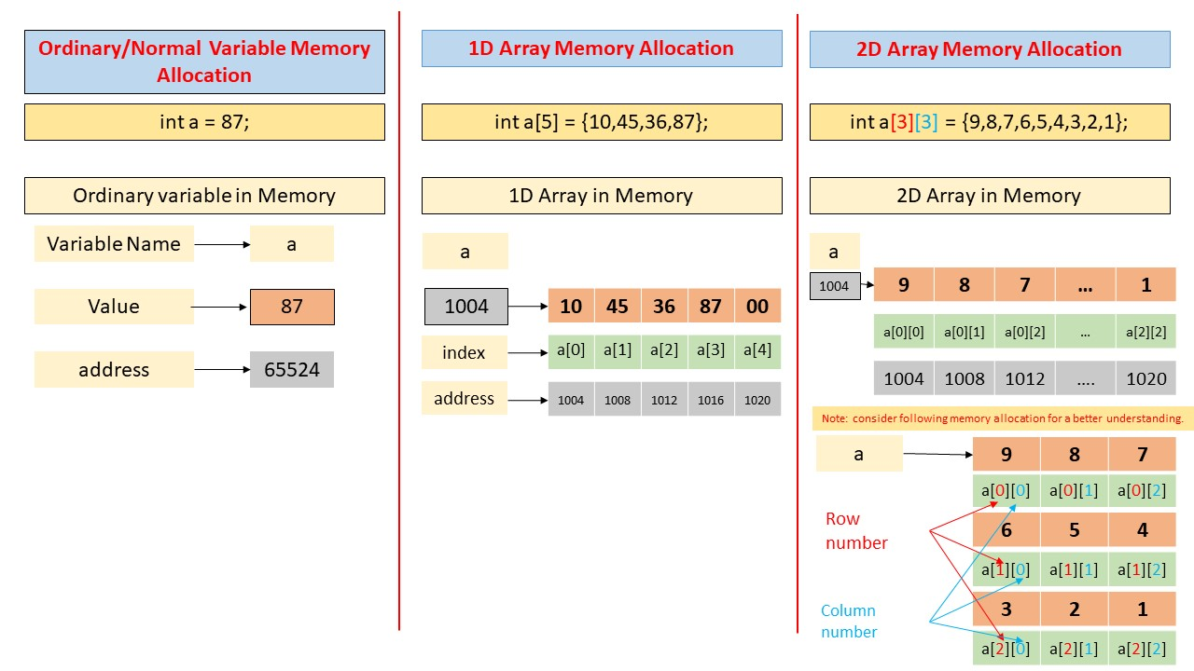

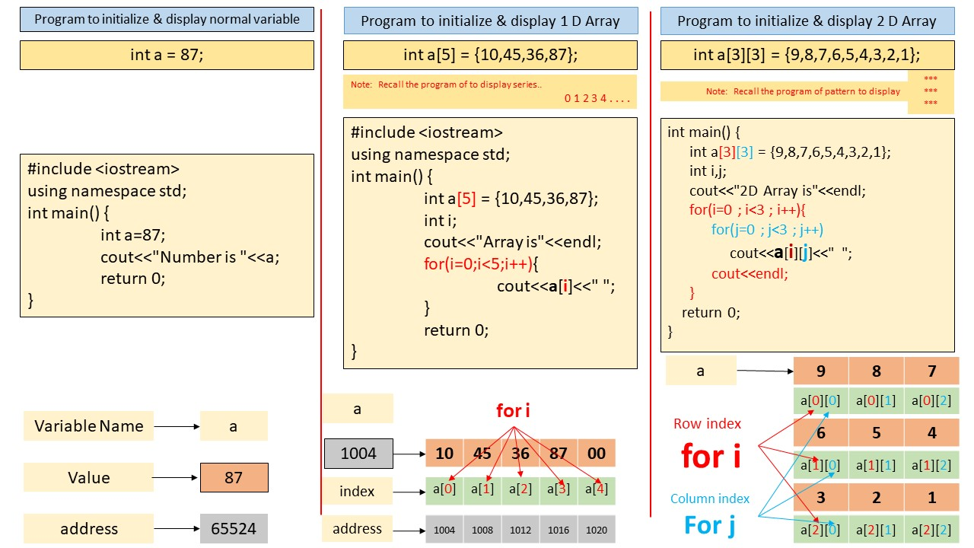  
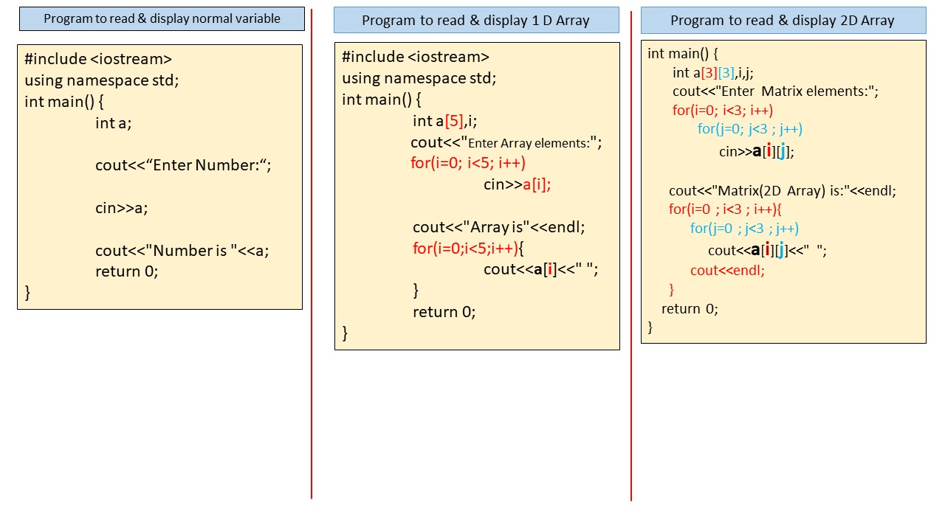

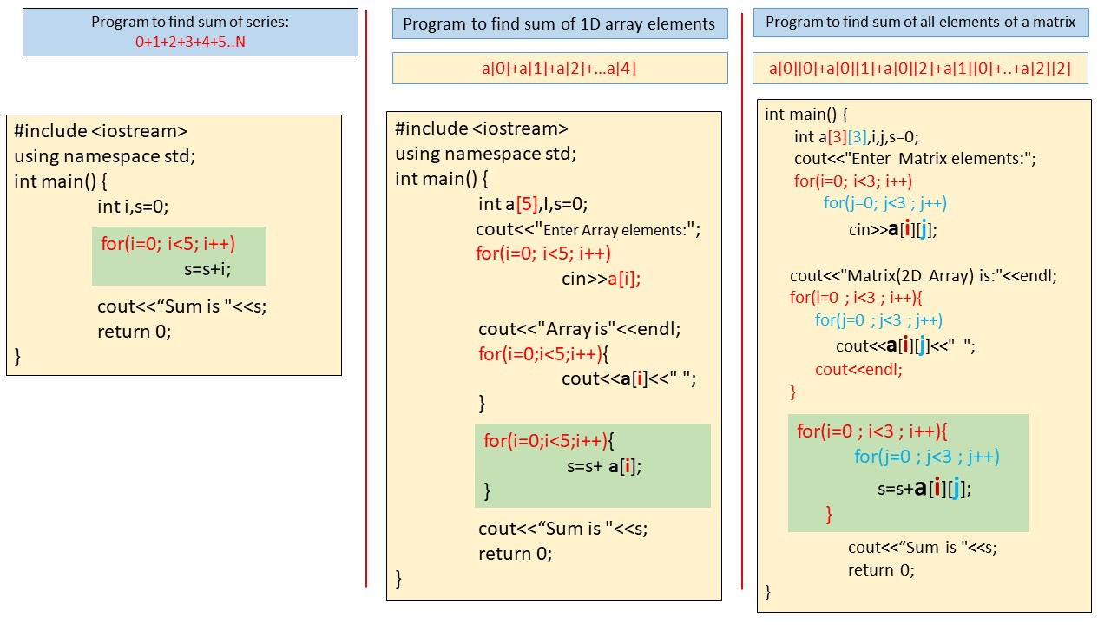

**Tasks:**

|  |  |
| --- | --- |
| Sr. No. | Problem Statement |
| 1 | Write a program to multiply each element of an array by 5 and display the resultant array. |
| 2 | Write a program to count and display number of odd & even elements from an array (1D) separately. |
| 3 | Implement a program to find the intersection of two arrays |
| 4 | WAP to copy one array into another array in reverse order. |
| 5 | Create a program to exchange first and last element of the 1D array of size N. |
| 6 | Develop a program to perform sum of elements of matrix (2D array) of order MXN. |
| 7 | Develop a program to find sum of elements of lower triangular matrix of order MxN. |
| 8 | Implement a program to find the largest element in matrix of order 3X3. |
| 9 | Write a program to perform multiplication of two matrix of order mXn and pXq and display the resultant matrix. |

**Practice Questions:-**

1. Write a program to find sum of odd & sum of even numbers from array separately
2. Write a program to find and display odd & even numbers from an array (1D) separately of size N.
3. WAP to copy one array into another array in reverse order.
4. Implement a program to reverse elements of 1D array and display it.
5. WAP to delete an element from an array.
6. Develop a program to copy one 1D array into another 1D array and display copied array.
7. WAP to find Sum of diagonal elements of MxN matrix.
8. WAP to find Sum of elements of upper triangular of MxN matrix.
9. WAP to find Matrix addition [of order mXn and pXq].